

NAME: BISMA FATIMA
CLASS: CS A
ROLL NO: F24605036
COURSE: DATA STRUCTURE
COURSE CODE: CS-211
LECTURER: SIR MEHRAN YOUSAF

LAB TASK 02

INLAB TASK
Task 1: Find Max and Min
Write a C++ program that initializes an array with at least 10 integer values. Implement a function that traverses the array to find and print the maximum and minimum values in the array without using any built-in sorting functions.
Program
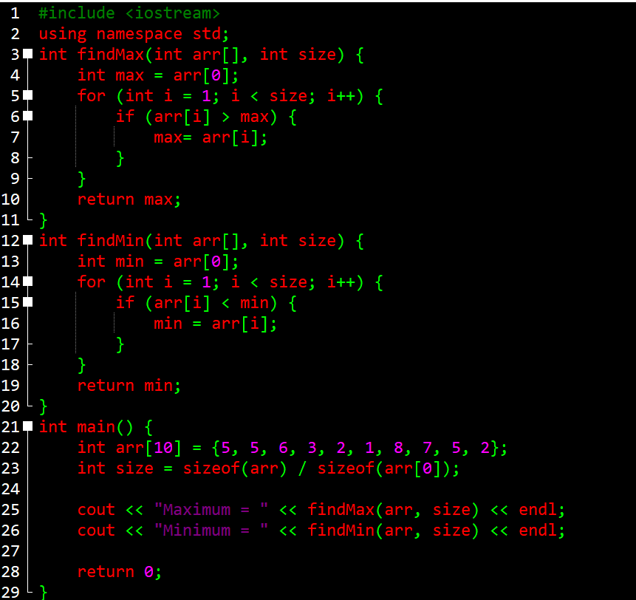
Output
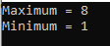
Task 2: Reverse the Array
Write a C++ program to reverse an array of integers. For example, if the array is [10, 20, 30, 40, 50], after reversal it should be [50, 40, 30, 20, 10]. Implement the reversal in-place, meaning you should not use a second array. (Hint: Use two pointers, one at the start and one at the end, and swap elements).
Program
1. #include <iostream>
2. using namespace std;
3.
4. void reverseArray(int arr[], int size) {
5. int start = 0;
6. int end = size - 1;
7.
8. while (start < end) {
9. // Swap elements at start and end
10. int temp = arr[start];
11. arr[start] = arr[end];
12. arr[end] = temp;
13.
14. // Move pointers toward the center
15. start++;
16. end--;
17. }
18. }
19.
20. int main() {
21. int arr[] = {10, 20, 30, 40, 50};
22. int size = sizeof(arr) / sizeof(arr[0]);
23.
24. cout << "Original array: ";
25. for (int i = 0; i < size; i++)
26. cout << arr[i] << " ";
27. cout << endl;
28.
29. reverseArray(arr, size);
30.
31. cout << "Reversed array: ";
32. for (int i = 0; i < size; i++)
33. cout << arr[i] << " ";
34. cout << endl;
35.
36. return 0;
37. }

Output
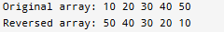

Task 3: Remove Duplicates from a Sorted Array
Given a sorted array of integers, write a function to remove the duplicate elements in-place. The function should return the new size of the array. For example, if the input array is [2, 2, 3, 5, 5, 5, 8], the array should be modified to [2, 3, 5, 8] and the function should return 4.
Program
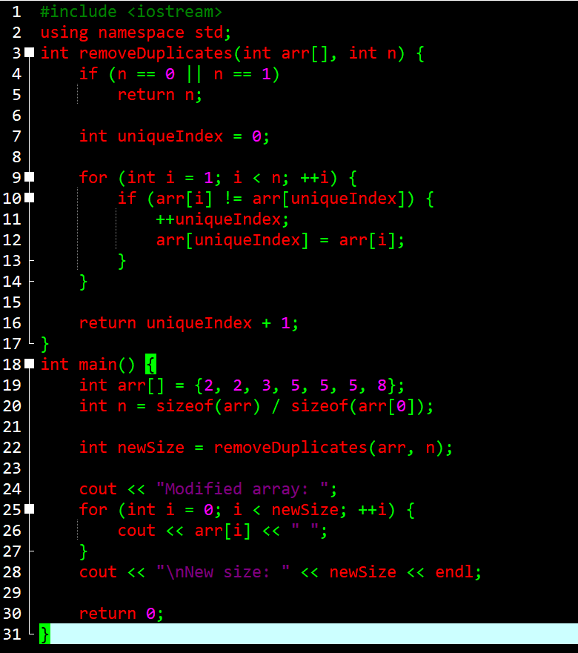
Output
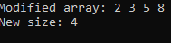

Task 4: Calculate Average and Sum
Write a program that takes 10 integer inputs from the user, stores them in an array, and then calculates and displays the sum and average of the elements.
Program
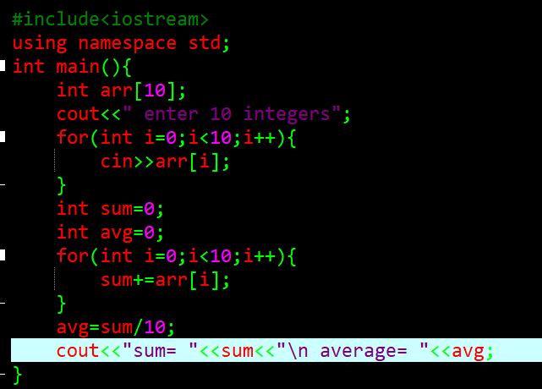
Output
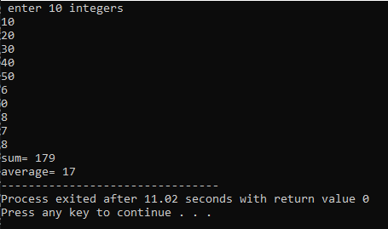s

POST LAB TASK
1: Rotate Array to the Right
Write a function rotate(int arr[], int size, int k) that rotates an array to the
right by k steps. k is a non-negative integer. You must do this in-place with
O(1) extra space.
- Example 1:
- Input:
arr = [1, 2, 3, 4, 5, 6, 7], k = 3
- Output:
[5, 6, 7, 1, 2, 3, 4]
Example 2:
- Input:
arr = [-1, -100, 3, 99], k = 2
- Output:
[3, 99, -1, -100]
Hint: Consider
what happens if k is greater than the size of the array. The modulo
operator (%) might be useful. One efficient approach involves reversing
parts of the array.
Program
1. #include <iostream>
2. using namespace std;
3. void reverse(int arr[], int start, int end) {
4. while (start < end) {
5. swap(arr[start], arr[end]);
6. start++;
7. end--;
8. }
9. }
10. void rotate(int arr[], int size, int k) {
11. if (size == 0 || k == 0) return;
12. k = k % size; // Handle cases where k > size
13. // Reverse the entire array
14. reverse(arr, 0, size - 1);
15. //Reverse the first k elements
16. reverse(arr, 0, k - 1);
17. // Reverse the remaining elements
18. reverse(arr, k, size - 1);
19. }
20. int main() {
21. int arr1[] = {1, 2, 3, 4, 5, 6, 7};
22. int size1 = sizeof(arr1) / sizeof(arr1[0]);
23. rotate(arr1, size1, 3);
24. for (int i = 0; i < size1; i++) cout << arr1[i] << " ";
25. cout << endl;
26.
27. int arr2[] = {-1, -100, 3, 99};
28. int size2 = sizeof(arr2) / sizeof(arr2[0]);
29. rotate(arr2, size2, 2);
30. for (int i = 0; i < size2; i++) cout << arr2[i] << " ";
31. cout << endl;
32.
33. return 0;
34. }

Output
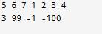
2: Find the Missing Number
You are given an array containing n distinct numbers taken from the range 0, 1, 2,
..., n. Since the array has only n numbers, exactly one number in that range is
missing. Write an efficient C++ function to find the missing number.
- Example:
- Input:
arr = [3, 0, 1]
- Output: 2
Hint: The sum of the first n natural numbers can be calculated with the formula n * (n +
1) / 2.
Program
1. #include <iostream>
2. using namespace std;
3.
4. int findMissingNumber(int arr[], int n) {
5. int natural_sum = n * (n + 1) / 2;
6. int actual_sum = 0;
7.
8. for (int i = 0; i < n; i++) {
9. actual_sum += arr[i];
10. }
11. return natural_sum - actual_sum;
12. }
13. int main() {
14. int arr[] = {3, 0, 1};
15. int n = sizeof(arr) / sizeof(arr[0]); // n is 3, but range is 0 to 3, so total numbers = 4
16. cout << "Missing number is: " << findMissingNumber(arr, n) << endl;
17. return 0;
18. }

Output
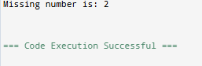
3: Merge Two Sorted Arrays
Write a function that merges two sorted arrays into a single sorted array. Do not use
any built-in sorting functions on the final merged array.
- Input: arr1 =
[1, 3, 5, 7], arr2 = [2, 4, 6, 8]
- Output: A new
array [1, 2, 3, 4, 5, 6, 7, 8]
- Constraint: You should create a third array with the combined size and fill it by
intelligently picking elements from the two input arrays.

Program
1. #include <iostream>
2. using namespace std;
3. void mergeSortedArrays(int arr1[], int size1, int arr2[], int size2, int merged[]) {
4. int i = 0, j = 0, k = 0;
5.
6. // Traverse both arrays and pick the smaller element
7. while (i < size1 && j < size2) {
8. if (arr1[i] < arr2[j]) {
9. merged[k++] = arr1[i++];
10. } else {
11. merged[k++] = arr2[j++];
12. }
13. }
14. // Copy remaining elements from arr1
15. while (i < size1) {
16. merged[k++] = arr1[i++];
17. }
18. // Copy remaining elements from arr2
19. while (j < size2) {
20. merged[k++] = arr2[j++];
21. }
22. }
23. int main() {
24. int arr1[] = {1, 3, 5, 7};
25. int arr2[] = {2, 4, 6, 8};
26. int size1 = sizeof(arr1) / sizeof(arr1[0]);
27. int size2 = sizeof(arr2) / sizeof(arr2[0]);
28. int merged[size1 + size2];
29.
30. mergeSortedArrays(arr1, size1, arr2, size2, merged);
31.
32. cout << "Merged array: ";
33. for (int i = 0; i < size1 + size2; i++) {
34. cout << merged[i] << " ";
35. }
36. cout << endl;
37.
38. return 0;
39. }

Output
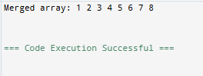
4: Finding a Subarray with a Given Sum (Sliding Window)
Given an array of non-negative integers, find a contiguous subarray that adds to a
given number (the target sum).
- Example:
- Input:
arr = [1, 4, 20, 3, 10, 5], targetSum = 33
- Output:
"Sum found between indexes 2 and 4" (because 20 + 3 + 10 = 33)
Hint: Use two pointers (a "sliding window") to define the current subarray.
Expand the window by moving the end pointer, and shrink it by moving the
start pointer.
Program
1. #include <iostream>
2. using namespace std;
3.
4. void findSubarrayWithSum(int arr[], int size, int targetSum) {
5. int start = 0, currentSum = 0;
6.
7. for (int end = 0; end < size; end++) {
8. // Add the current element to the window
9. currentSum += arr[end];
10.
11. // Shrink the window from the start if currentSum exceeds targetSum
12. while (currentSum > targetSum && start < end) {
13. currentSum -= arr[start];
14. start++;
15. }
16.
17. // Check if we found the target sum
18. if (currentSum == targetSum) {
19. cout << "Sum found between indexes " << start << " and " << end << endl;
20. return;
21. }
22. }
23.
24. cout << "No subarray with the given sum found." << endl;
25. }
26.
27. int main() {
28. int arr[] = {1, 4, 20, 3, 10, 5};
29. int size = sizeof(arr) / sizeof(arr[0]);
30. int targetSum = 33;
31.
32. findSubarrayWithSum(arr, size, targetSum);
33.
34. return 0;
35. }

Output
